TITLE OF PROJECT

City Tour

PROJECT REPORT

By

Saurabh Raj Singh

15STUHH0109

Department of Computer Science

ICFAI Foundation For Higher Education

Shankarpally,Hyderabad

**Abstract**

Tourism Management System is a complete tourist fully integrated tourism web site. The website covers all the areas required for an including tourism, This project is developed to manage the tourist in the tourism management web site.My project is completely based on HTML and CSS.

**INTRODUCTION**

The city Search is an online Guide that provides basic description about top cities of India. My project is based on front end only. It is basically designed for touring Incredible India.

**Technology Used**

Front End:HTML and CSS

Editor:HTML Toolkit

**Overiew about Project**

HTML:

HTML stands for **H**yper**t**ext **M**arkup **L**anguage, and it is the most widely used language to write Web Pages.

* **Hypertext** refers to the way in which Web pages (HTML documents) are linked together. Thus, the link available on a webpage is called Hypertext.
* As its name suggests, HTML is a **Markup Language** which means you use HTML to simply "mark-up" a text document with tags that tell a Web browser how to structure it to display.

Originally, HTML was developed with the intent of defining the structure of documents like headings, paragraphs, lists, and so forth to facilitate the sharing of scientific information between researchers.

Now, HTML is being widely used to format web pages with the help of different tags available in HTML language.

CSS:

Like your web page, a cascading style sheet consists of ASCII text instructions telling the browser how it can format the document that is being loaded. The CSS instructions can be placed in the web page itself, or it can be placed in a separate document which is linked to the web page.

The simplest way to explain a cascading style sheet is to give an example of one.

Take the following code, for example, inserted in the HEAD section of a web page.

<style type="text/css">  
body {  
  background-color: white ;  
  color: black ;  
  font-family: Arial, Helvetica, sans-serif ;  
}  
</style>

In a browser that understands style sheets, the code above would cause the page to have a white background and black text. The text in the body would be displayed using either the Arial typeface, the Helvetica typeface, or if neither are available, some other sans serif typeface. It has the same effect as a <body> HTML tag that has the "background" and "text" attribute, followed by a <font> tag

HTML Toolkit Editor:

**HTML-Kit** is a proprietary [HTML editor](https://en.wikipedia.org/wiki/HTML_editor) for [Microsoft Windows](https://en.wikipedia.org/wiki/Microsoft_Windows) made by [chami.com](http://www.chami.com/). The [application](https://en.wikipedia.org/wiki/Application_software) is a full-featured [HTML editor](https://en.wikipedia.org/wiki/HTML_editor)designed to edit, format, validate, preview and publish web pages in [HTML](https://en.wikipedia.org/wiki/HTML), [XHTML](https://en.wikipedia.org/wiki/XHTML) and [XML](https://en.wikipedia.org/wiki/XML) -languages.

HTML-Kit is [freeware](https://en.wikipedia.org/wiki/Freeware), although extra features are available at a cost to registered users.

An [Alpha](https://en.wikipedia.org/wiki/Software_release_life_cycle#Alpha) [version](https://en.wikipedia.org/wiki/Software_versioning), HTML-Kit Tools (previously named build 300), is in development and is currently only available for download by registered users. Build 292, the current stable build is available for download as freeware.

**Home Page**

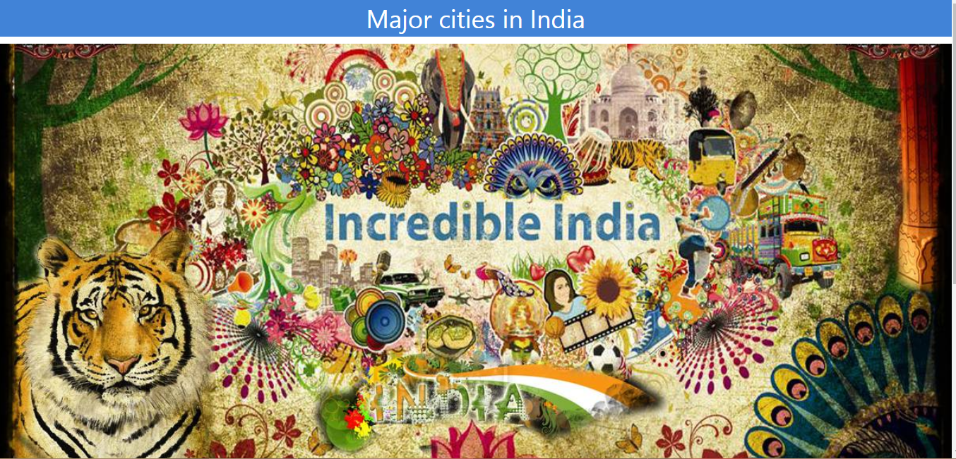

Top 10 City In India:

1.Bengaluru

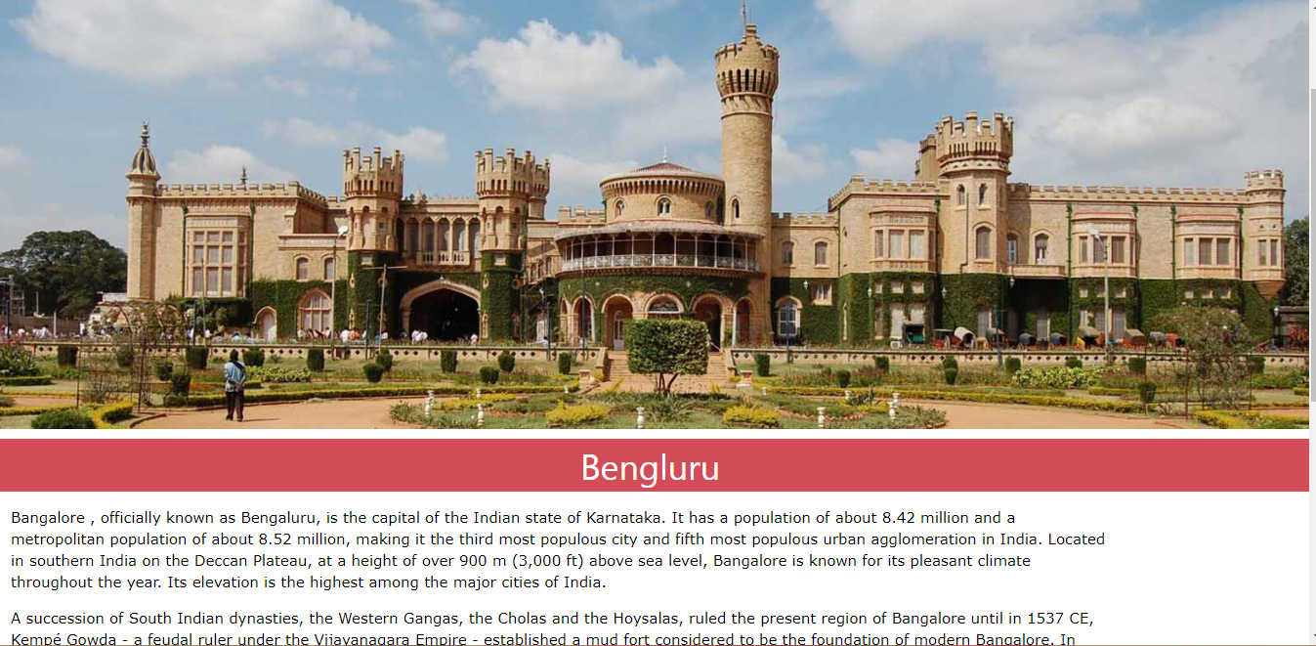

2.Delhi

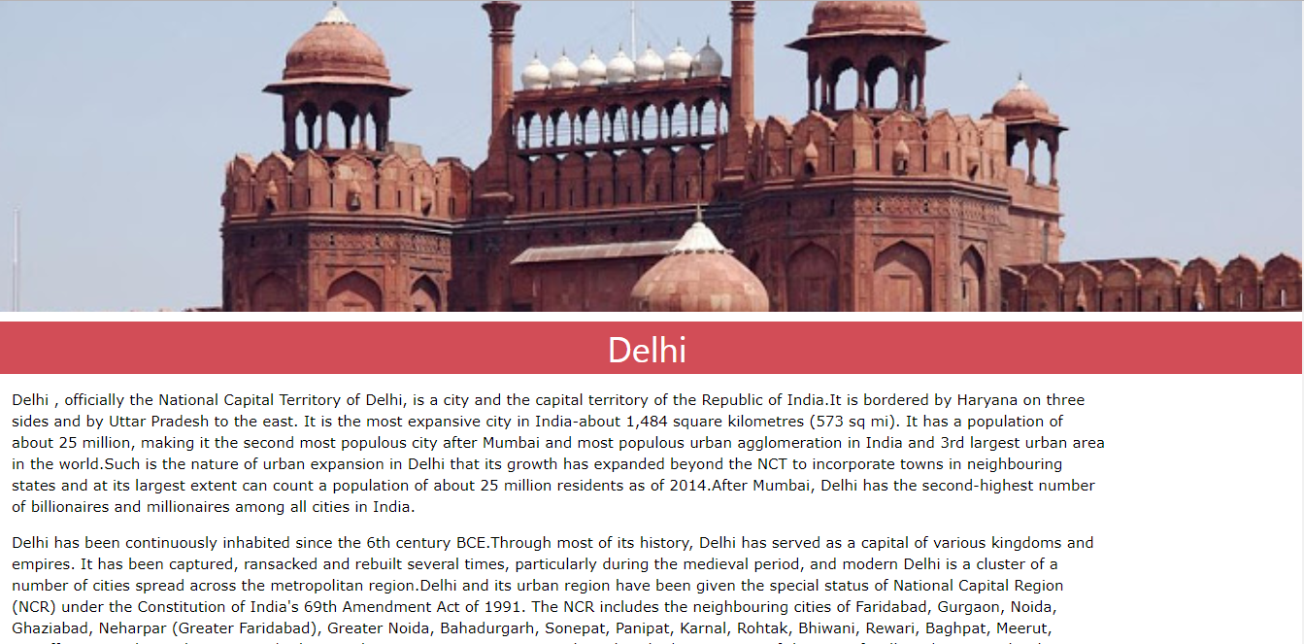

3.Kolkata

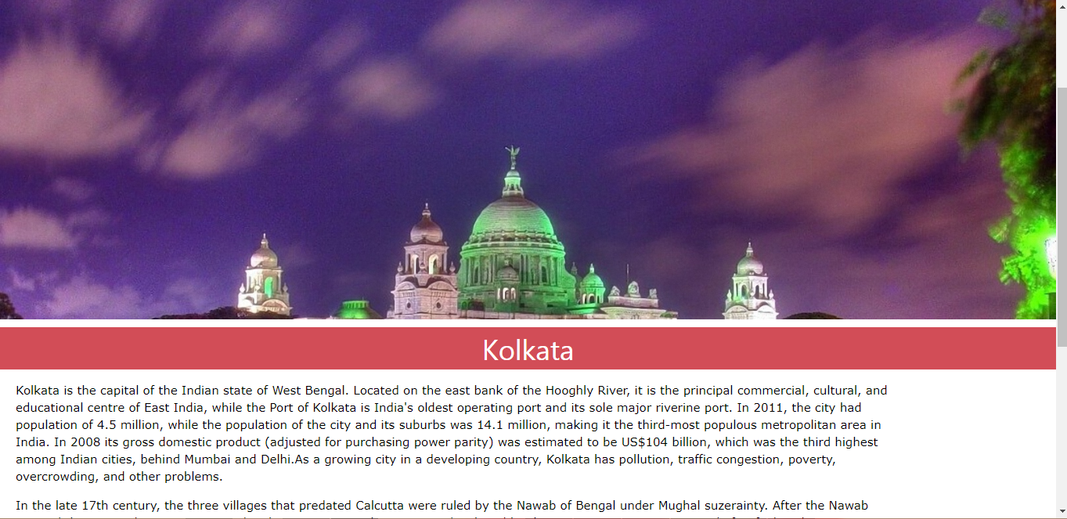

4.Varanasi

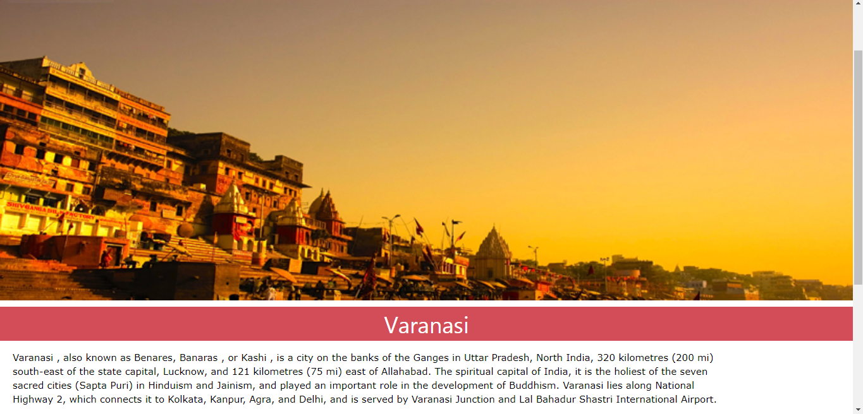

5.Mumbai

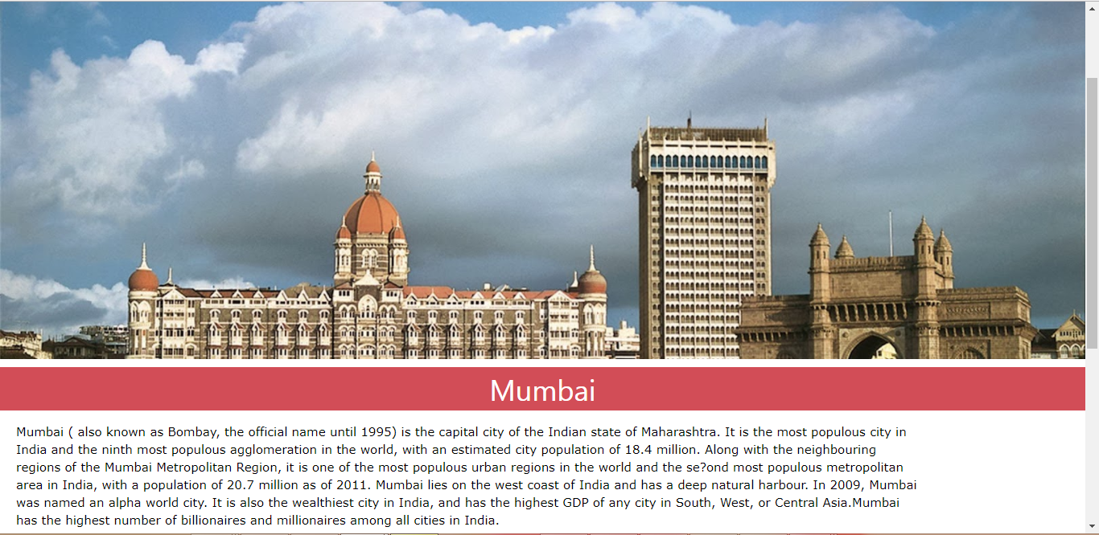

6.Chennai

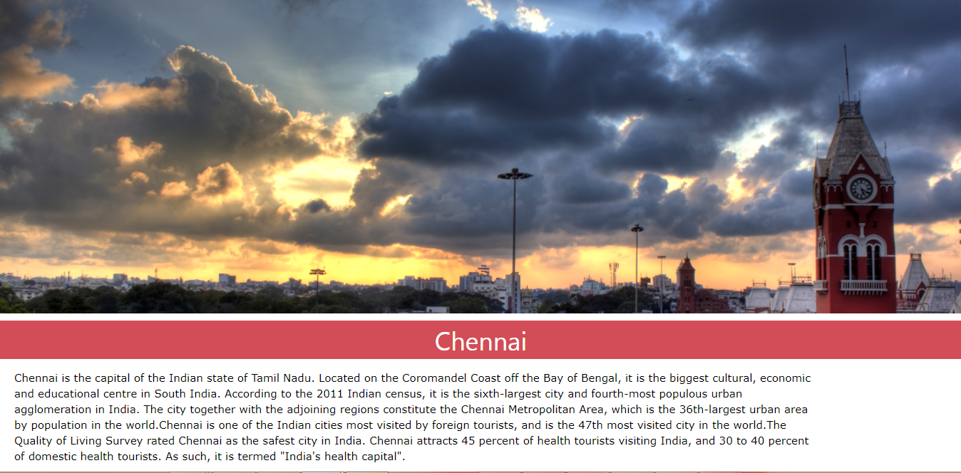

7.Ahmedabad

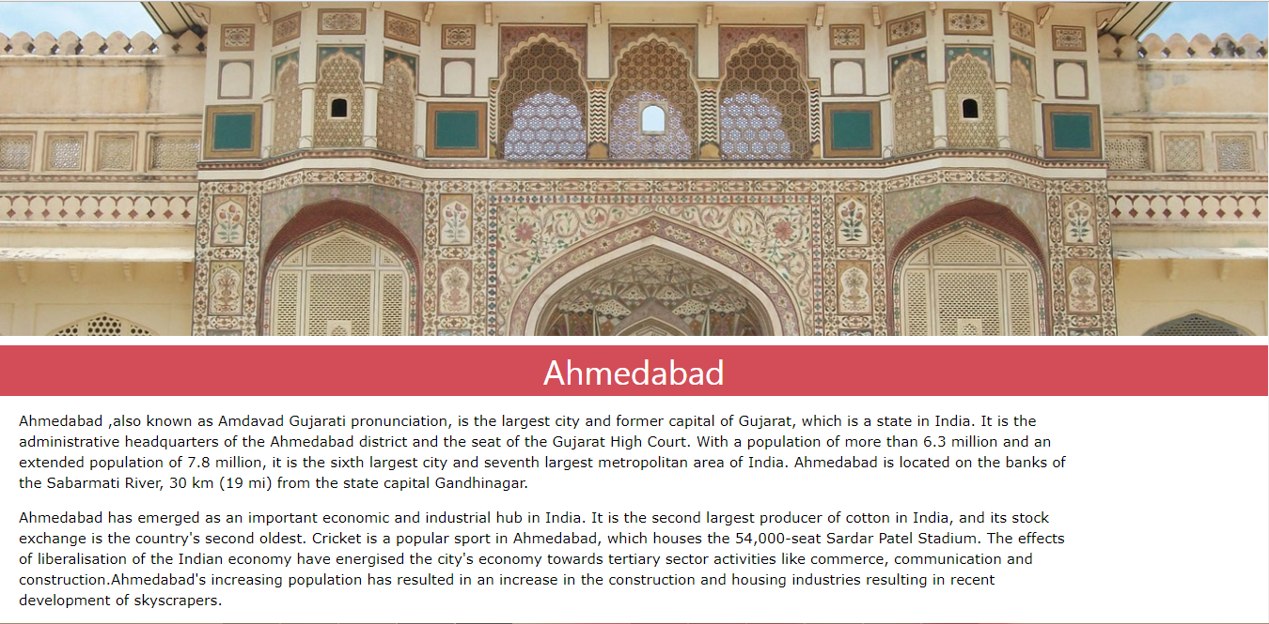

8.Hyderabad

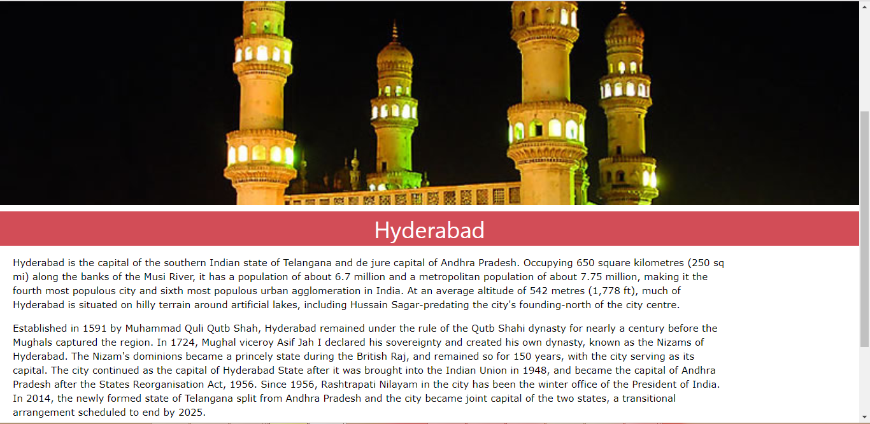

9.Gurgaon

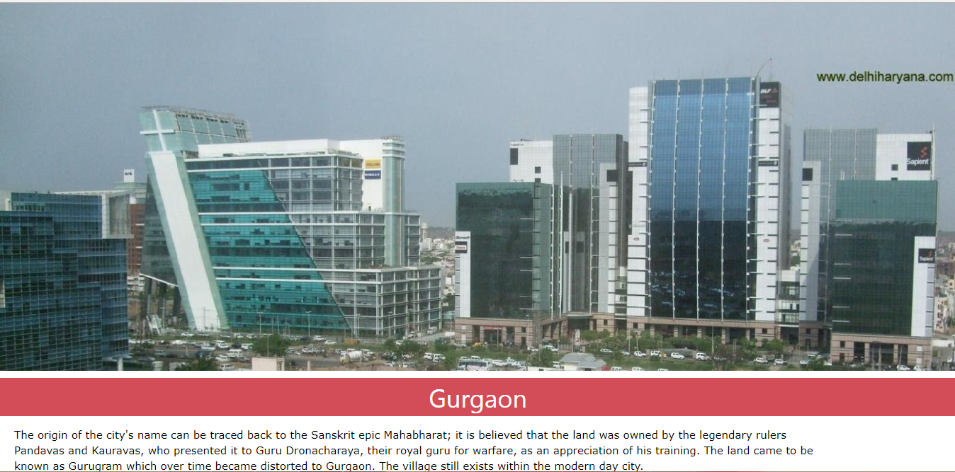

10.Agra

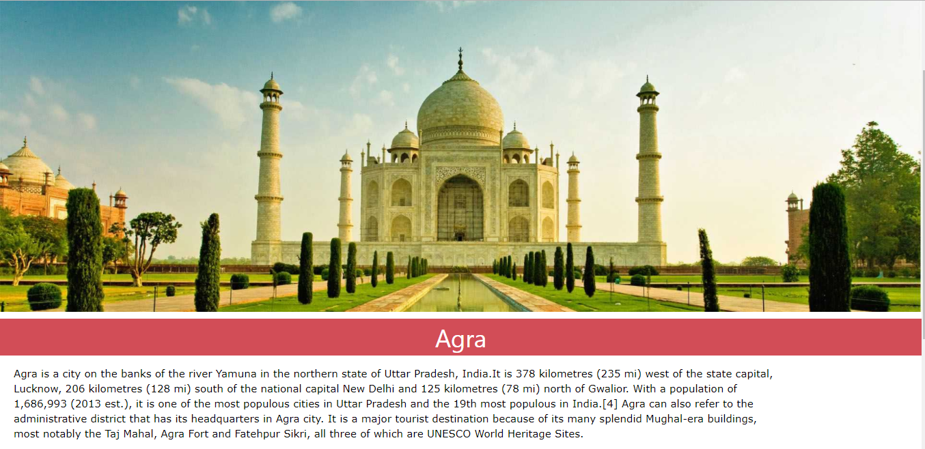

**References:**

W3Shools

Tutorialspoint